CyberCafe CyberSafe Application Information and User Guide

# 2. Application Features

The CyberCafe CyberSafe application is designed to ensure a safer internet environment for children. It offers various functionalities such as submitting incident reports via Hotline and Helpline forms, as well as web browsing through a WebView. Users can report incidents related to cyberbullying, hacking, fraud, and other forms of cybercrime.

# 3. Additions

The application includes forms for reporting incidents, which are hosted online and support anonymous information submission. Additionally, it features a WebView browsing capability, allowing direct access to services like the Hotline and Helpline.

# 4. Application Screenshots

## Home Screen

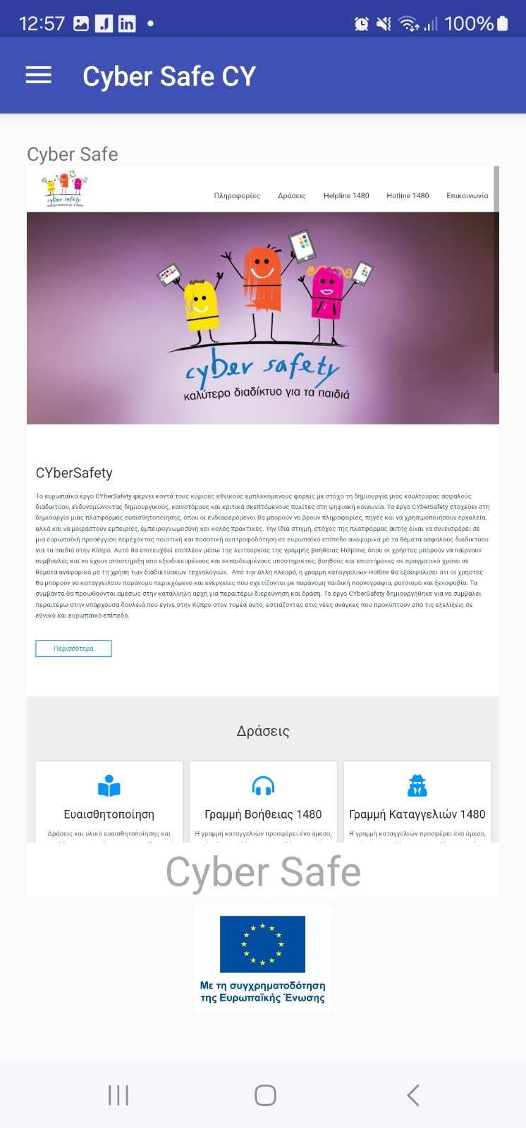

The Home Screen provides navigation options and access to key features such as Hotline and Helpline.

## Menu Navigation

The navigation menu allows users to select different options, including accessing forms to report incidents.

## Hotline Form

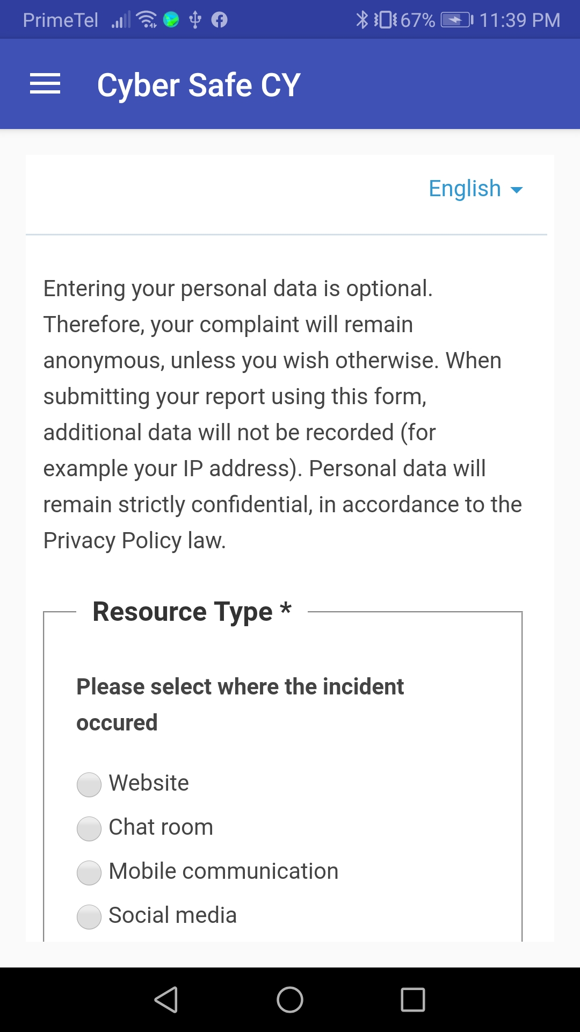

The Hotline form, where users can submit incident reports related to cybercrime.

## Helpline Form

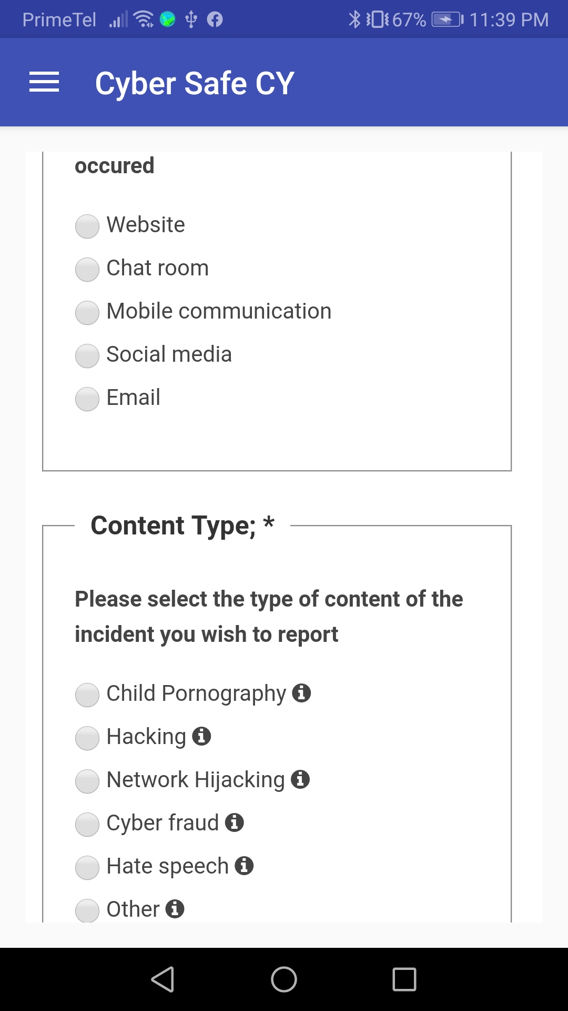

The Helpline form, which supports users in reporting cyber-related issues.

# 5. User Guide

To use the application, start from the Home Screen and select the desired option from the menu. You can submit reports via the Hotline and Helpline forms by selecting the type of incident, filling out the necessary fields, and completing the CAPTCHA for submission.